TEST REPORT

Travelling Bot :

A chat bot is a computer program use to communicate with the user. The bot can service plenty of customers simultaneously, handling orders and simple questions right away. It is a best option for the person who don’t want their customer to wait. Chat bot answer the customer automatically via text messages.

How Do Chatbot’s Work?
Chatbots, at least all the usable versions, use something the community calls NLP, which is short for Natural Language Processing. This is not to be confused with Neuro-linguistic programming NAL (Natural Language Processing), which deals with the analysis and processing of natural language.
A chatbot whose main objective is to simulate a conversation like its human creators would need to process and understand the common language.

Travelling Bot Features :
Travelling Bot can guide a customer different mediums for travelling from Place A to B It can generate few AI based responses as well to interact with customer.
Natural Language Processing is Enabled in this bot.
Mediums Supported are listed below:
Bus , Taxi Services (uber, etc) , Walking ,By Own Car
Outputs:
Fares, Distances, Mediums Availability, Expected Time Duration
Weather Forecast

Benefits of Chatbots in Travel:
Better Customer Service:
Chatbots have the potential to deliver seamless customer service. Whether it is about communicating urgent information or providing solutions to immediate problems, chatbots can handle it all. Your customers will always feel your support system by their side irrespective of their time zone. This is something travelers always need particularly during international travels. By being there for your customers for every need they have you will be able to provide an improved level of customer service.
Improved Engagement:
A chatbot is one such customer touchpoint which ensures maximum engagement. It is even more engaging than human assistants because there are no time boundaries. Travel bots are able to solve queries, give recommendations, initiate transactions or just have casual interactions. With so many possibilities comes the added benefit of all time availability. This ensures improved customer's engagement with your brand even more than a mobile app or social media.
Cost Effective:
Bot development is highly cost-effective. With the power of artificial intelligence, chatbots are able to solve many customer problems of routine nature. This means you no longer need to outsource to 3rd party customer care centers. Additionally, new travel startups can skip app development and directly move to bots to save resources.
Saves Time:
Chatbots can handle routine queries and save the precious time of customer service representatives. This will enable them to handle more complex customer problems and lay focus on other complex managerial activities. If your bot is skilled to handle customer problems then this can ease the workload on the many airline employees from ground staff to cabin crew. It will also save customers’ time that is spent in reaching out to service executives and listening to that 30 min long solo music on the helpline!
Access to Data:
Chatbots record each of their communication with the users. This means that they can collect data that gives insights into the customer experience, purchase history, problems etc. This will help companies to gain a 360-degree view of their customers. Using the insights generated from chatbots, companies can send personalized marketing messages. This will bring in the personal touch awaited by the customers since a long time. From the customer’s perspective, they will always have access to the chat history so they can refer their queries at any point of time.

APIs:
This project have highly rely on APIs and be built in Python framework. This section will introduce some key APIs used by us to build our bot
Uber Fare Estimator API:
Weather API:
Google GeoCode API:
Google Directions API:
Uber Fare Estimator API:
The Uber Fare Estimator API is a pre-built web service that can do to Find the Estimate of the Uber, We have use the Uber Official API v1.2
Weather API:
The Weather API is a pre-built web service that can provide us weather current data and forecast conditions of Nigeria.
Google GeoCode API:
Google GeoCode API is use to find the address or it is also use to convert address in geographic coordinates.
Google Directions API:
Google Directions API is a prebuilt web service of Google map platform that can calculates directions between two locations. You can search for directions for several modes of transportation.

Supported Locations:
This bot support some location that are enabled in this bot.
Here is the list of the location
Lagos
Abuja
Port Harcourt

Test Cases for Chat bots:
Due to the unique nature of this project I decided to conduct some conversational tests.
I will outline a conversational path I wish to take and then test it against a live bot and see how it plays out.
Get Started Button:
First I click on the Get Started button and enter to the bot.
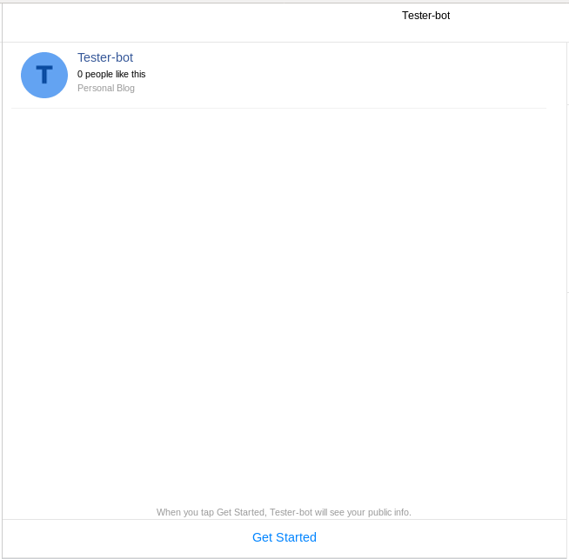

Bot Chat:
user can chat with the bot and ask about the location and fare estimate.
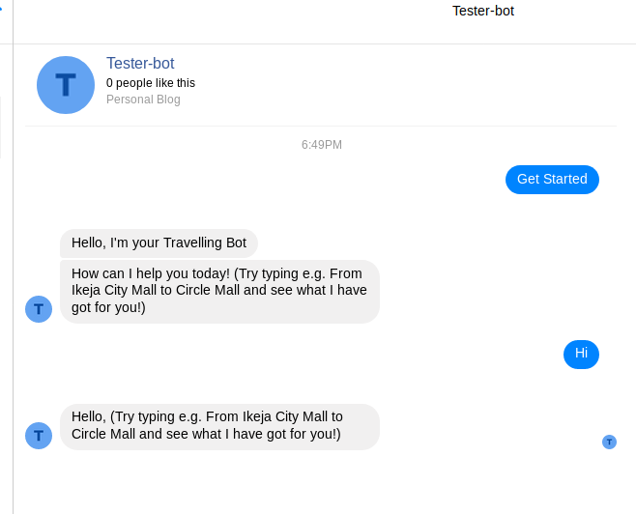

For testing purposes, we gave some wrong words to the bot and the bot’s response that he doesn't know the words.
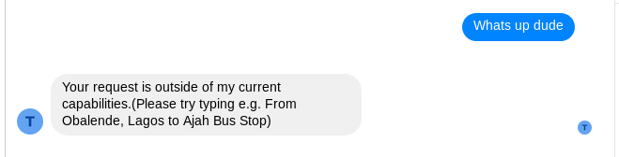

Fare Estimate:
And then I ask the bot to show me the fare estimate and I enter pickup and drop off location,The bot replies the fare estimate.
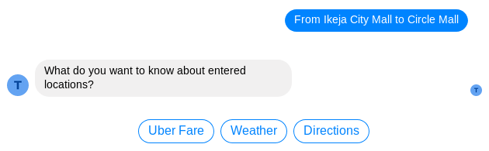
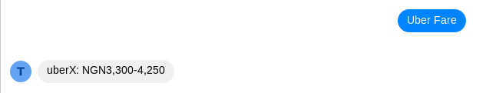

Conclusion:
The main objectives of the project were to develop an algorithm that will be used to identify answers related to user submitted questions. This bot help the user to find his direction,weather update and fare estimate of the place where user want to go with the help of API the bot give exact same thing what the user want.

